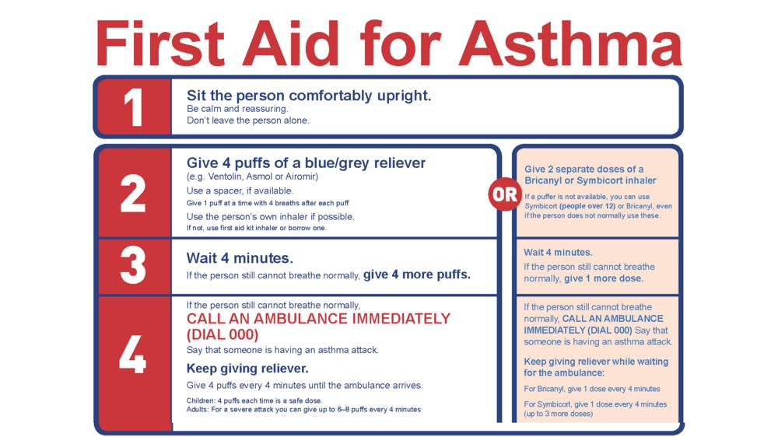
If someone still cannot breathe, ring 999

999

