Spring Term 2 – Song Sheet

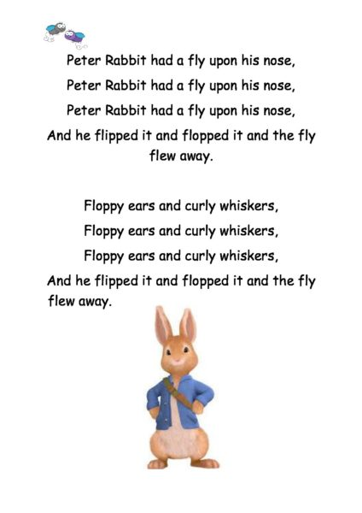

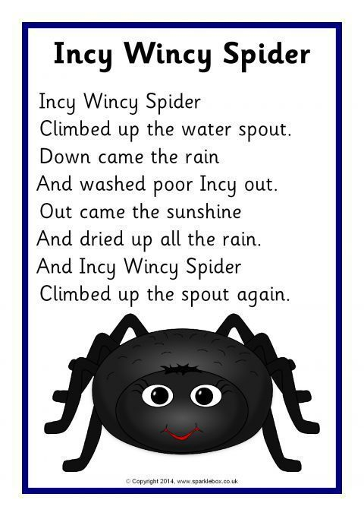

*Sleeping Bunnies*

*See the little bunnies sleeping til it’s nearly noon  
Shall we wake them, shall we wake them, with a merry tune?  
Oh so still, are they ill?  
No! Wake up bunnies!  
Hop little bunnies, hop, hop, hop  
Hop little bunnies, hop, hop, hop  
Hop little bunnies, hop, hop, hop  
Hop little bunnies, hop and stop.*

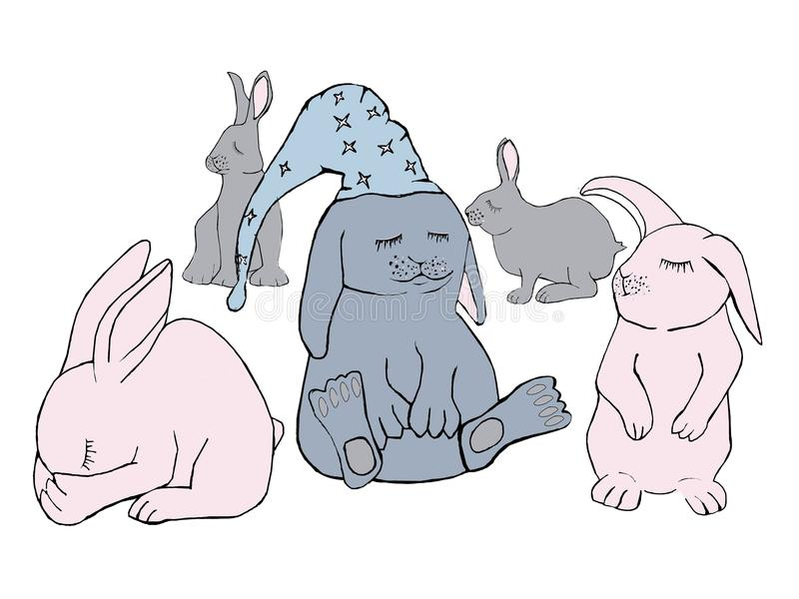

**Old MacDonald had a farm..**

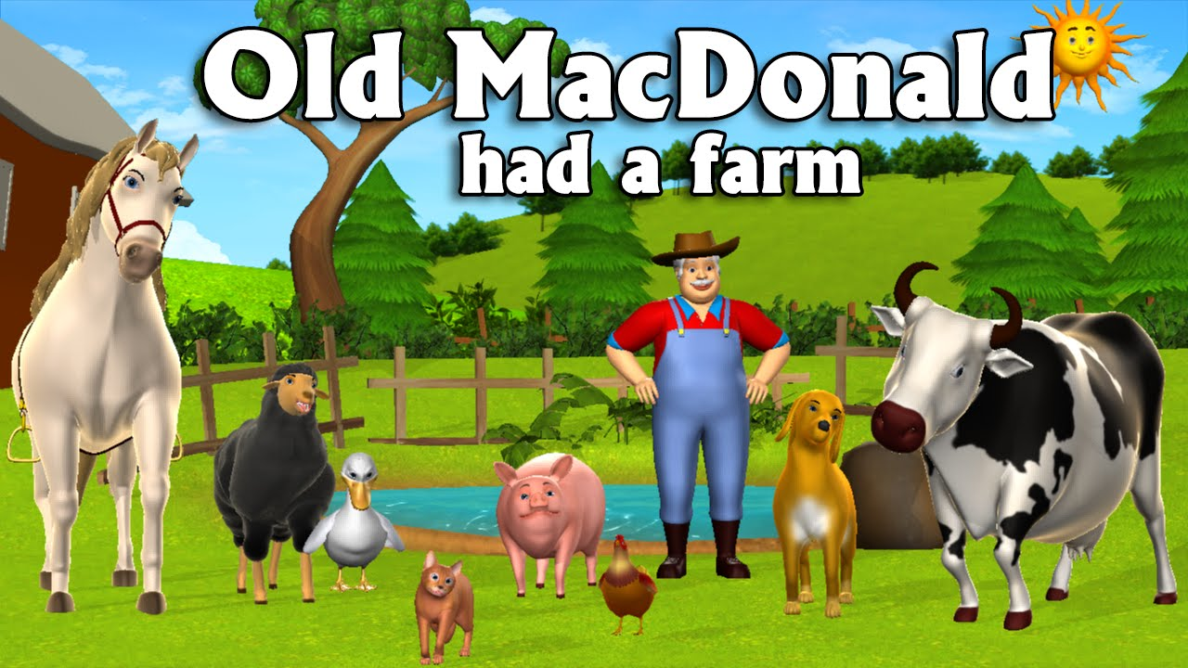

Old MacDonald had a farm,

Ee i ee i o  
And on his farm he had some cows  
Ee i ee i oh  
With a moo-moo here  
And a moo-moo there  
Here a moo, there a moo  
Everywhere a moo-moo  
Old MacDonald had a farm  
Ee i ee i o  
Old MacDonald had a farm  
Ee i ee i o  
And on his farm he had some chicks  
Ee i ee i o  
With a cluck-cluck here  
And a cluck-cluck there  
Here a cluck, there a cluck  
Everywhere a cluck-cluck  
Old MacDonald had a farm  
Ee i ee i o  
Old MacDonald had a farm  
Ee i ee i o  
And on his farm he had some pigs  
Ee i ee i o  
With an oink-oink here  
And an oink-oink there  
Here an oink, there an oink  
Everywhere an oink-oink  
Old MacDonald had a farm  
Ee i ee i o