

curiosity grows.

**If children are happy, they will achieve.**

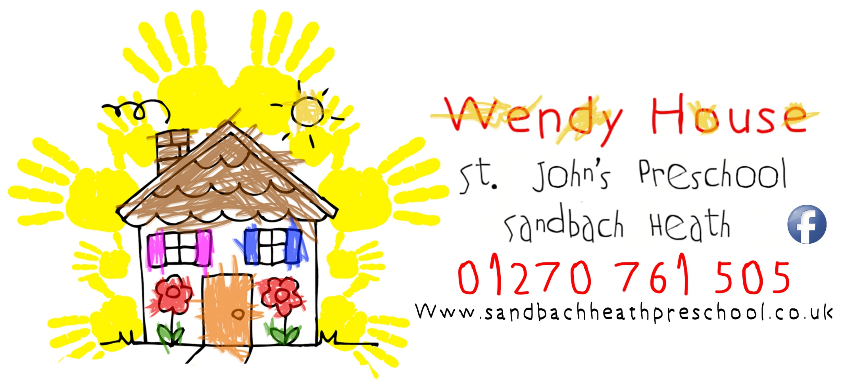

**Where knowledge is nurtured…….**

**Our Vision**

Our mission is to provide high quality education and childcare in a safe respectful inclusive environment that builds the foundations for lifelong learning.

Our Vision and Mission Statement

**Our Vision**

A community where all children feel loved and respected, and encouraged to develop to their fullest.