

Autumn Term 1 – My World, Your World.
Welcome!
Welcome to all the new children and your families. We have enjoyed our first couple of weeks settling in and getting to know each other. All the children have started to settle into preschool and are making some great relationships with their peers and teachers.
The autumn term the topics are:
Autumn 1: My world, your world.
Autumn 2: Magical lands and mythical creatures in far-away places.
This half term the children will learn that the world is full of all sorts of people, speaking different languages, eating different foods and living different kinds of lives. The children will learn to embrace and celebrate their uniqueness and that of others. They will start to develop and demonstrate their feelings and emotions, talk about how they and others show feelings and talk about their own and others behaviour, and its consequences.
Drop off/ Pick up.
Please can all make sure the gate is closed at all times and watch your children when parents/carers are coming in and out.

Please like us at:
Sandbach Heath Preschool, to follow what your children have been busy doing!


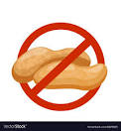
NO NUTS PLEASE!
Please do not bring any nuts into our setting, peanut butter or products with nuts listed in the ingredients.


This week we will be setting up the parent partnership WhatsApp, this will be used to upload photos/videos of your child’s learning through preschool.


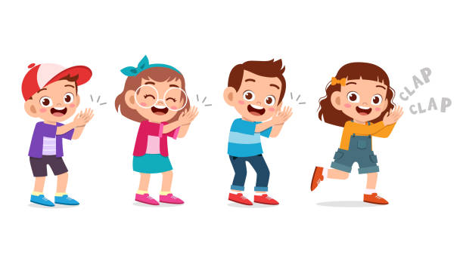
During Autumn Term 1, we are focusing on these 4 nursery rhymes/songs,
Head, shoulders knees and toes
Family Fingers
If You’re Happy and You Know It
Frère Jacques
if possible, please could you sing these songs at home with your children.
Nursery rhymes play an important role in our children’s early lives, particularly the
development of crucial language and communication skills.

