Spring 2 – Song Sheet Continued
One man went to mow…..

One man went to mow, went to mow a meadow.
One man and his dog
Went to mow a meadow.

Two men went to mow
Went to mow a meadow
Two men, one man and his dog
Went to mow a meadow.

Three men went to mow
Went to mow a meadow
Three men, two men, one man
And his dog.
Went to mow a meadow.
Four men went to mow
Went to mow a meadow.
Four men, three men, two men, one man
And his dog
Went to mow a meadow.

Five men went to mow
Went to mow a meadow
Five men, four men, three men, two men, one man
And his dog
Went to mow a meadow.
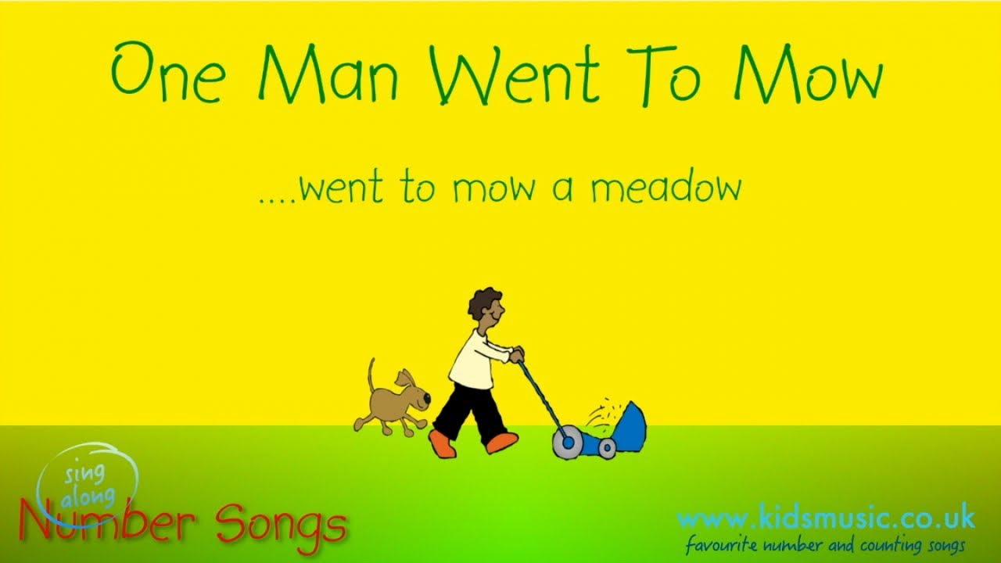
B-I-N-G-O
There was a farmer who had a dog,
And Bingo was his name-o.
B-I-N-G-O
B-I-N-G-O
B-I-N-G-O
And Bingo was his name-o.
There was a farmer who had a dog,
And Bingo was his name-o.
(clap)-I-N-G-O
(clap)-I-N-G-O
(clap)-I-N-G-O
And Bingo was his name-o.
There was a farmer who had a dog,
And Bingo was his name-o.
(clap)-(clap)-N-G-O
(clap)-(clap)-N-G-O
(clap)-(clap)-N-G-O
And Bingo was his name-o.
There was a farmer who had a dog,
And Bingo was his name-o.
(clap)-(clap)-(clap)-G-O
(clap)-(clap)-(clap)-G-O
(clap)-(clap)-(clap)-G-O
And Bingo was his name-o.
There was a farmer who had a dog,
And Bingo was his name-o.
(clap)-(clap)-(clap)-(clap)-O
(clap)-(clap)-(clap)-(clap)-O
(clap)-(clap)-(clap)-(clap)-O
And Bingo was his name-o.
There was a farmer who had a dog,
And Bingo was his name-o.
(clap)-(clap)-(clap)-(clap)-(clap)
(clap)-(clap)-(clap)-(clap)-(clap)
(clap)-(clap)-(clap)-(clap)-(clap)
And Bingo was his name-o.


