See the little bunnies sleeping till it’s nearly noon

Shall we wake them shall we wake them with a merry tune?

Oh how still, shh, are they ill?

Are they? ‘NO’

Wake up little bunnies!

Hop little bunnies hop hop hop

Hop little bunnies hop hop hop

Hop little bunnies hop hop hop

Hop little bunnies hop and stop

See the little chicks sleeping in the morning sun

Shall we wake them shall we wake them with a tickle on the tum

Oh how still, shh, are they ill?

Are they? ‘NO’

Wake up little chicks!

Cheep little chicks, cheep cheep cheep

Cheep little chicks, cheepitty cheep

Cheep little chicks, cheep cheep cheep

Cheep little chicks, cheep and sleep

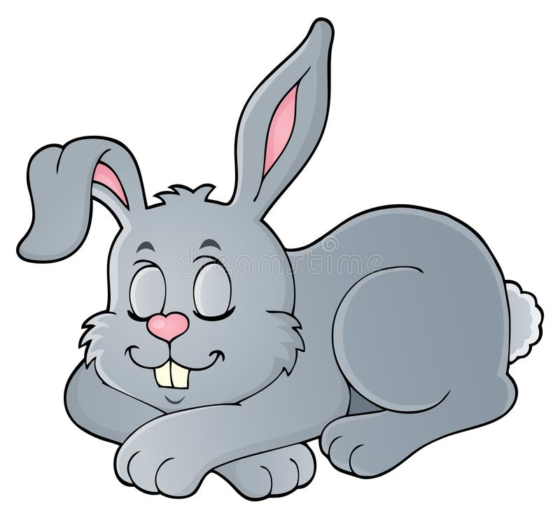

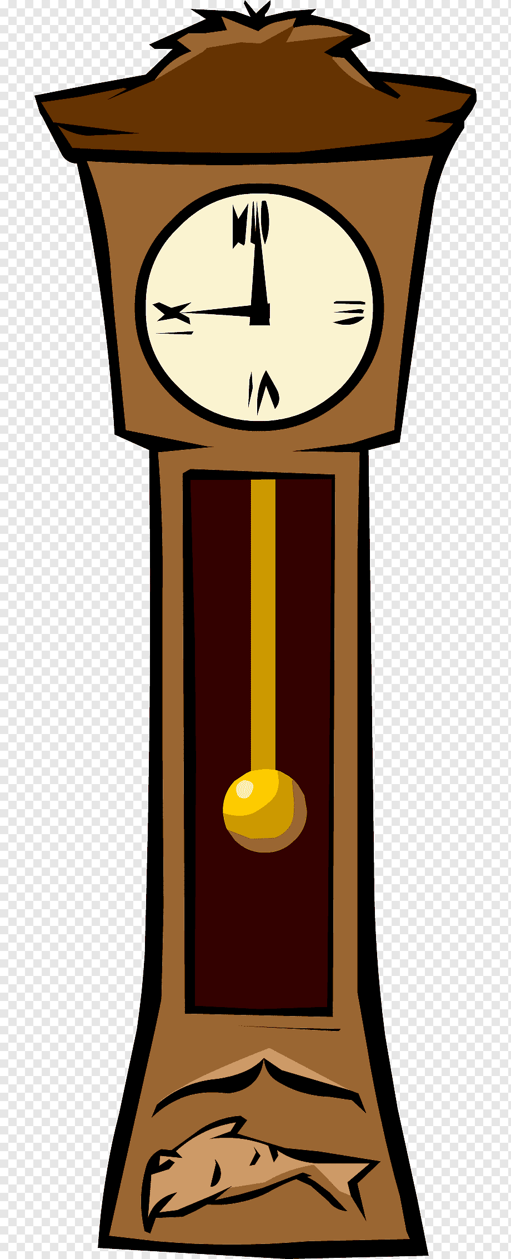

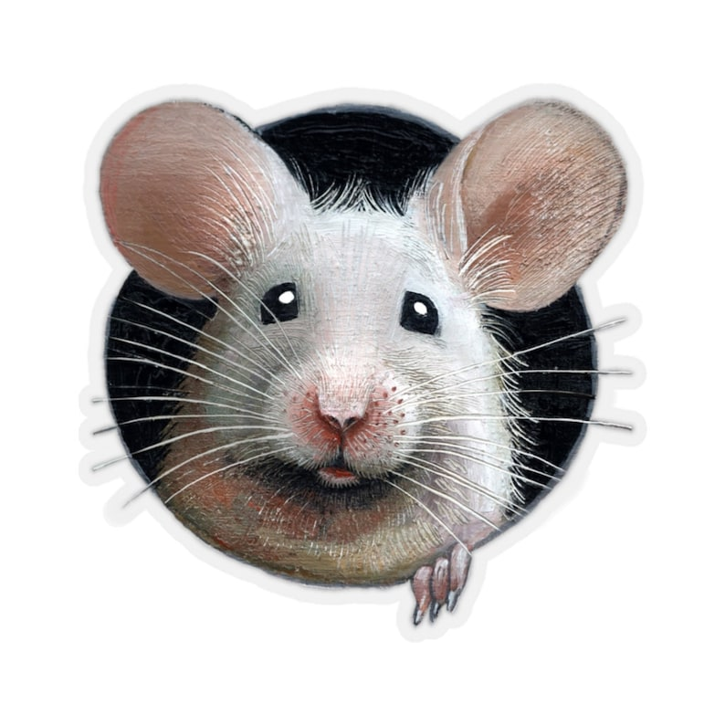

***Hickory Dickory Dock***

*Hickory dickory dock*

*The mouse ran up the clock*

*The clock struck one*

*The mouse ran down*

*Hickory dickory dock*

*Hickory dickory dock*

*The mouse ran up the clock*

*The clock struck two*

*The mouse went ‘boo’*

*Hickory dickory dock*

*Hickory dickory dock*

*The mouse ran up the clock*

*The clock struck three*

*The mouse went ‘wee’*

*Hickory dickory dock*

Hickory dickory dock

The mouse ran up the clock

The clock struck four

The mouse said ‘no more’

Hickory dickory dock

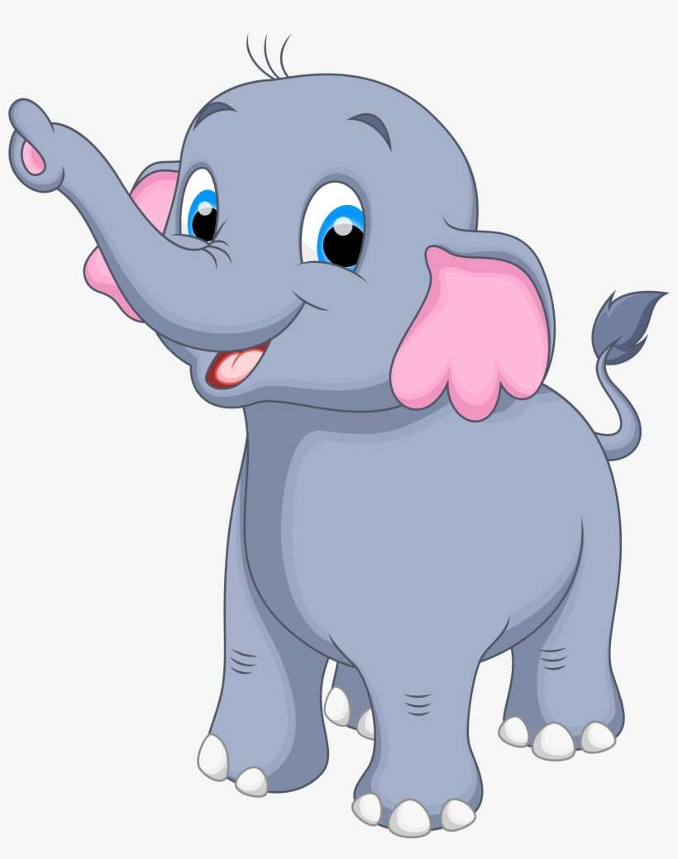

**DOWN IN THE JUNGLE**

Down in the jungle where nobody goes,

There’s a great big **elephant** washing his clothes.

With a rub a dub here and a rub a dub there,

That’s how an **elephant** washes his clothes.

He goes **stomp, stomp** a boogie

woogie woogie,

**stomp, stomp** a boogie

woogie woogie,

**stomp, stomp** a boogie

woogie woogie.

That’s how an **elephant** washes his clothes.

Down in the jungle where nobody goes

There’s a great big **lion** washing his clothes…..

He goes **roar, roar,** a boogie

woogie woogie …..

Down in the jungle where nobody goes

There’s a great, big **monkey** washing his clothes….

He goes **Ooo ooo,** a boogie

woogie woogie……

Down in the jungle where nobody goes

There’s a great, big **crocodile** washing his clothes……

He goes **snap, snap,** a boogie

woogie woogie…..