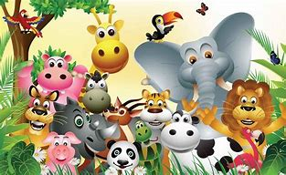

Spring Term 1 – The Wonderful World of Animals.

This half term the children will be provided opportunities to learn about wild animals, the sounds they make and their differences. The children will be able to join in with the repetitive refrains and create their own animal sounds.

From the confines of the zoo the children will break free to become explorers venturing through the noisy, vibrant jungle during the heat of the day, venturing into the tuneful moonlit night. Travelling onwards to swamps where alligators roam in the rainforest. We will find many amazing differences as we explore the habitats of the diverse rainforest and noisy jungle. We will use exciting books to celebrate the diversity of the animal kingdom. This encourages use of the language of size and explores the different features of a wide range of animals from around the world.

Most importantly we will learn to respect the animals we research, not only should children be empathetic to others, but to animals as well. Animals experience emotion and children who are gentle and respectful to animals are more likely to be respectful and empathetic to humans.

A great way to teach children about animals and how to respect them is by observing them in their natural environments. This can be practiced right from outside preschool or from outside your own homes by simply observing and pointing out animals to your children that you come across during your walks and tell your children about how the environment allows for the animals you see to live happy lives. Your children are sponges for learning. That’s why it’s so important to get them excited about learning from an early age.

**During this term we are focusing on these 4 nursery rhymes/songs:**

-Down in the Jungle (Try asking Alexa for this one, ‘Alexa, play down in the jungle’)



-B.I.N.G.O.

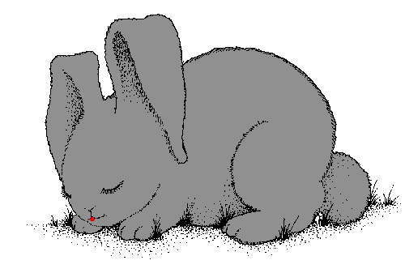

-Hickory Dickory Dock.

-Sleeping Bunnies.

If possible, please could you sing these songs at home with your children.

Drop off/ Pick up.

Please can all make sure the gate is closed at all times, watching your children when parents are coming in and out.



School Place Deadline

Application process closing on the

**15th January 2023**

Dates for the Diary

February Half Term

Holidays- **Friday 18th February**

Returning **Monday 28th February**

