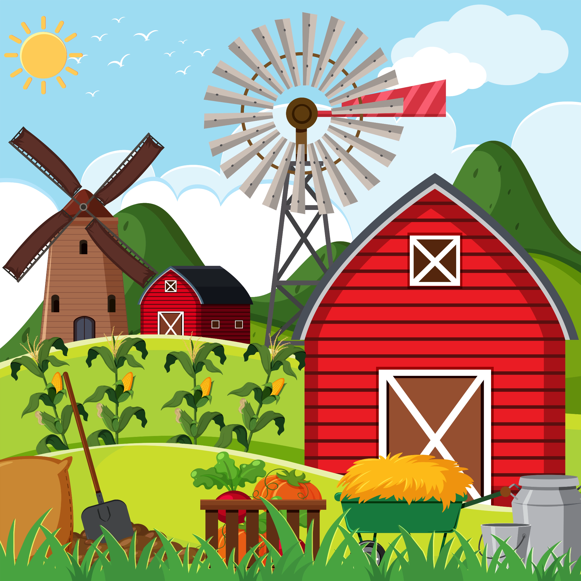
Spring Term 2 – Farms, fields and hedgerows.

This half term the children will be provided opportunities to learn about different types of farms including how the farms work, what they produce, and how they relate to our lives, this will include:
What life on a farm is like.
Different jobs a farmer does.
The use of tractors and machinery.
Different animals that live on farms.
The range of food and vegetables that are grown.

The children will be exploring stories that see animals having amazing adventures, packed full of songs, alliteration and rhyme. We will make wonderful props to enhance our story telling and explore the noises animals make with ‘What’s that Sound?’ This builds towards one of the core aims in the specific area, 'Understanding The World' as children find out more about how real life works on farms (understanding the environment).
We will enter the world of incredible transformations, where creatures such as butterflies begin life their life as tiny eggs, metamorphosing into majestic multicoloured winged butterflies. We will join the children in the story as they find out about the insect’s life cycle. The children will encounter the magic of minibeasts. We will be exploring the pre-school grounds, woods, surrounding fields and hedgerows for insects and become detectives of the past, present, and the future. We will plant seeds that will grow into flowers that will attract wildlife.
During this we are focusing on these 5 nursery rhymes/songs:
-Sleeping bunnies
-One man went to mow
B.I.N.G.O
-Peter Rabbit
- Old MacDonald had a farm
If possible, please could you sing these songs at home with your children.
Also, two familiar favourites for the holiday, Five Speckled Frogs and Incy Wincey Spider.
Drop off/ Pick up.
Please can all parents/carers ensure the gate is closed at all times. Please watch your children when other parents, carers are coming in and out.

Dates for the Diary
Easter Half Term Holiday
Close: Friday 31st March. Returning: Monday 17th April.

Red nose Day
Friday 17th March- wear something red. We will be selling red noses during the week.

Pupil Absences
If your child will be absent from preschool, please inform us by 9:00 am, either via WhatsApp
or
Tel. 01270 761505

World Book Day.
The children are invited to bring in a book from home and dress up as a favourite character.
From Monday 27th February to Friday 3rd March 2023

